Mosquito Picture | Scientific Name | Common Name | Distinctive Features | Disease/s Carried | Ecology | Bite | Additional Information
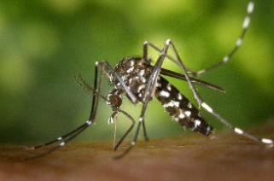 | Aedes albopictus | Asian Tiger | - Black and silver color  - Striped legs  - Single, silver stripe on thorax  - Silver bands on abdomen  - Sharp abdomen  - Unmarked wings | - Dengue  - Chickungunya  - West Nile Virus | Containers; Anything that holds water (flower pots, gutters, tires) | Daytime | Mostly seen after rains; controlled by habitat and larvae; Pesticide moderately effective
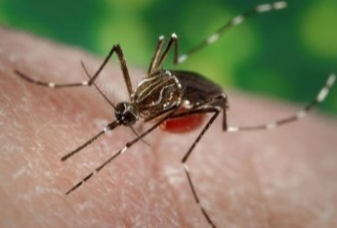 | Aedes aegypti | Yellow fever mosquito | - Lyre shape on thorax  - Striped legs  - Dusty black color  - Dark unmarked wings  - Sharp abdomen  - Basal bands on abdomen | - Dengue  - Chickungunya  - Yellow fever | Artificial containers | Daytime | Feed on humans; Historically found in OK (not as common now); Major disease vector; Often confused with Aedes albopictus
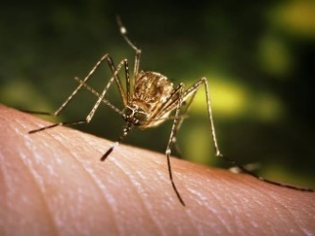 | Culex tarsalis | Western House Mosquito | - Striped, lined legs  - Bands on abdomen  - Blunt abdomen  - Dark, unmarked wings  - Lightly patterned thorax | - West Nile Virus | Polluted waters | Evening | Prefers birds to humans; Found more in western areas
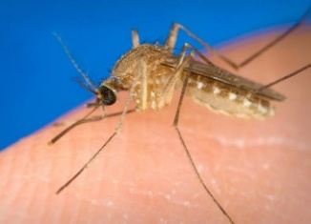 | Culex quinquefasciatus | Southern House Mosquito | - Tan Color  - Dark Legs  - Bands on abdomen  - Blunt abdomen  - Dark, unmarked wings  - Plain, tan thorax | - West Nile Virus  - Saint Louis Encephalitis  - Eastern Equine Encephalitis  - Western Equine Encephalitis | Polluted Waters | Evening | Feeds on humans and birds; most often bite in the evening; Type most often collected at THD
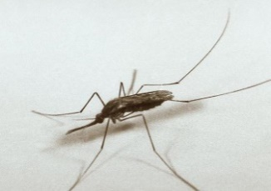 | Anopheles quadrimaculatus | Malaria Mosquito | - Palin dark thorax  - Dark, blunt, unmarked abdomen  - 4 spots on dark wings  - Long dark palps  - Dark legs | - Malaria  - Heartworm | Ponds; Lake margins; Around emergent vegetation | Night | Prefers to feed on humans
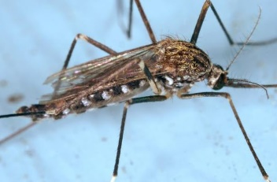 | Aedes japonicus | Asian bush mosquito | - Brown color  - Striped legs, dark hind tarsi  - Golden striped thorax  - Bands only on ventral abdomen  - Sharp abdomen  - Dark unmarked wings | - West Nile Virus | Rock pools | Not specified | Invasive; not commonly found; not a major pest
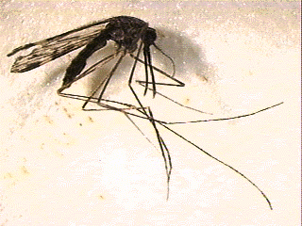 | Anopheles pseudopunctipennis | Dapple winged mosquito | - Long striped palps  - Marked wings  - Light patterning on the thorax  - Blunt, dark abdomen  - Dark legs | - Dog heartworm | Stream edges | Not specified | More abundant during dry periods; Feed on large mammals and humans
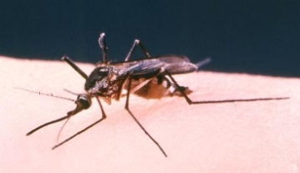 | Aedes triseriatus | Eastern tree hole mosquito | - Sharp Abdomen  - Dark, unbanded abdomen  - Dark brown/silver color  - Dark unmarked wings  - Dark legs  - Thorax with silver band and wide silver bands on sides | - Lacrosse encephalitis | Tree holes and artificial containers and floodwaters | Not specified | Nuisance to man; big in size
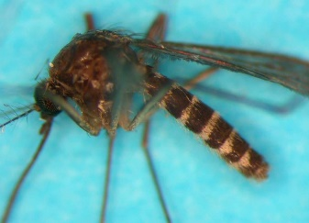 | Culex erraticus | N/A | - Blunt abdomen  - Small in size  - Dark brown color  - Bands on abdomen  - Dark, unmarked wings  - Dark legs | - Possible West Nile Virus | Grassy pond edges; slow streams | Not specified | Not usually a pest to humans; Vector of West Nile Virus birds; Associated with Anopheles quadrimaculatus
**Other notable mosquitoes:
Culiseta inorata – aka. Winter Mosquito, not known to carry disease; found in cooler temperatures
Aedes epatius – aka. Southern Rock Pool Mosquito; not known to carry disease
Orthopodomyia – not known to carry disease

